SIMATS ENGINEERING
ASSESSMENT TOOL 1

COURSE CODE: CSA51 COURSE NAME: Cryptography and Network Security

COURSE OUTCOME COVERED

CO4: Implement best security practices for IP, email, and web service using PGP, S/MIME for enhancing email Security.CO (BL3, BL6)

Assessment Tool Weightage: 40%

QUESTIONS: 5 TOTAL MARKS: 25

Annexure A
Coding Challenge

Code of Conduct:

I HAYAGRIVA R.A(192521006)certify that this submission is my original work and that I have adhered to the guidelines specified for this assessment.
I understand that any violation of academic integrity rules will result in disciplinary action.

Signature of the student: HAYAGRIVA R.A

Annexure A
Coding Challenge

- Write a program to simulate the IPSec Authentication Header (AH) process that generates and verifies a message authentication code (MAC) for IP packet integrity.
IPSec Authentication Header (AH)
Steps:
- Model an IP packet with a mix of mutable fields (TTL, header checksum — legitimately changed by routers in transit) and immutable fields (source/destination IP, identification, payload).
- Sender computes the ICV as HMAC-SHA256(SA_key, immutable_header_fields || payload) — zeroing mutable fields first, exactly as RFC 4302 specifies.
- Attach SPI + sequence number + ICV as the AH; transmit.
- Receiver recomputes the ICV the same way and compares with hmac.compare_digest (constant-time, avoids timing side-channels).
- Verified three cases: legitimate TTL decrement (passes), payload tampering (fails), and a replayed packet (rejected by the sequence-number check).
Code:
import hmac
import hashlib
import os
import struct

# ---------- Step 1: Simplified IP packet model ----------
class IPPacket:
"""
A simplified IPv4-like header. Only fields relevant to demonstrating
AH's "mutable vs immutable" distinction are modeled.
"""
def __init__(self, src_ip, dst_ip, ttl, identification, payload: bytes):
self.version_ihl = 0x45 # IPv4, header length 5 words (fixed)
self.ttl = ttl # MUTABLE -> decremented by every router
self.identification = identification # IMMUTABLE for this simulation
self.src_ip = src_ip # IMMUTABLE (spoofing this is what AH prevents)
self.dst_ip = dst_ip # IMMUTABLE
self.header_checksum = 0x0000 # MUTABLE -> recalculated by every router
self.payload = payload

def _ip_to_bytes(self, ip: str) -> bytes:
return bytes(int(octet) for octet in ip.split("."))

def to_bytes(self, for_icv: bool = False) -> bytes:
"""
Serialize the packet. If for_icv=True, zero out mutable fields
(TTL, header checksum) exactly as RFC 4302 requires before hashing.
"""
ttl_field = 0 if for_icv else self.ttl
checksum_field = 0 if for_icv else self.header_checksum

header = struct.pack(
"!BBHHB", # version_ihl, ttl, identification, checksum, placeholder
self.version_ihl,
ttl_field,
self.identification,
checksum_field,
0,
)
header += self._ip_to_bytes(self.src_ip)
header += self._ip_to_bytes(self.dst_ip)
return header + self.payload

# ---------- Step 2: AH sender-side processing ----------
class AH_Sender:
def __init__(self, sa_key: bytes, spi: int):
self.sa_key = sa_key # Security Association shared secret
self.spi = spi # Security Parameters Index (identifies the SA)
self.sequence_number = 0 # anti-replay counter

def protect(self, packet: IPPacket):
self.sequence_number += 1
icv_input = packet.to_bytes(for_icv=True)
icv = hmac.new(self.sa_key, icv_input, hashlib.sha256).digest()
ah_header = {
"spi": self.spi,
"sequence_number": self.sequence_number,
"icv": icv,
}
return packet, ah_header

# ---------- Step 3: AH receiver-side verification ----------
class AH_Receiver:
def __init__(self, sa_key: bytes, spi: int):
self.sa_key = sa_key
self.spi = spi
self.last_seen_sequence = 0

def verify(self, packet: IPPacket, ah_header: dict) -> bool:
# (a) SPI check -- correct Security Association?
if ah_header["spi"] != self.spi:
print(" [FAIL] SPI mismatch -- wrong Security Association")
return False

# (b) Anti-replay check -- sequence number must be new
if ah_header["sequence_number"] <= self.last_seen_sequence:
print(" [FAIL] Sequence number replay/out-of-order detected")
return False

# (c) Recompute ICV over the immutable fields and compare
icv_input = packet.to_bytes(for_icv=True)
expected_icv = hmac.new(self.sa_key, icv_input, hashlib.sha256).digest()

if hmac.compare_digest(expected_icv, ah_header["icv"]):
self.last_seen_sequence = ah_header["sequence_number"]
print(" [PASS] ICV matches -- integrity and origin authenticity verified")
return True
else:
print(" [FAIL] ICV mismatch -- packet was tampered with in transit")
return False

# ---------- Demonstration ----------
if __name__ == "__main__":
sa_key = os.urandom(32) # shared secret established during IKE, simulated here
spi = 0x1001

sender = AH_Sender(sa_key, spi)
receiver = AH_Receiver(sa_key, spi)

print("=== Scenario 1: Legitimate packet, TTL changes in transit ===")
pkt = IPPacket("192.168.1.10", "192.168.1.20", ttl=64, identification=555,
payload=b"Deposit request: amount=500")
pkt, ah = sender.protect(pkt)
print(f"Sent -> SPI={hex(ah['spi'])}, SeqNo={ah['sequence_number']}, "
f"ICV={ah['icv'].hex()[:16]}...")

# Simulate a router legitimately decrementing TTL -- must NOT break verification
pkt.ttl -= 1
print(f"(Router decremented TTL to {pkt.ttl} -- this is normal, not tampering)")
receiver.verify(pkt, ah)

print("\n=== Scenario 2: Attacker tampers with the payload in transit ===")
pkt2 = IPPacket("192.168.1.10", "192.168.1.20", ttl=64, identification=556,
payload=b"Deposit request: amount=500")
pkt2, ah2 = sender.protect(pkt2)
pkt2.payload = b"Deposit request: amount=999999" # attacker modifies payload
print("(Attacker altered payload amount from 500 to 999999)")
receiver.verify(pkt2, ah2)

print("\n=== Scenario 3: Replay attack -- attacker resends a previously captured packet ===")
receiver.verify(pkt, ah) # re-send the Scenario-1 packet/AH again

Output:
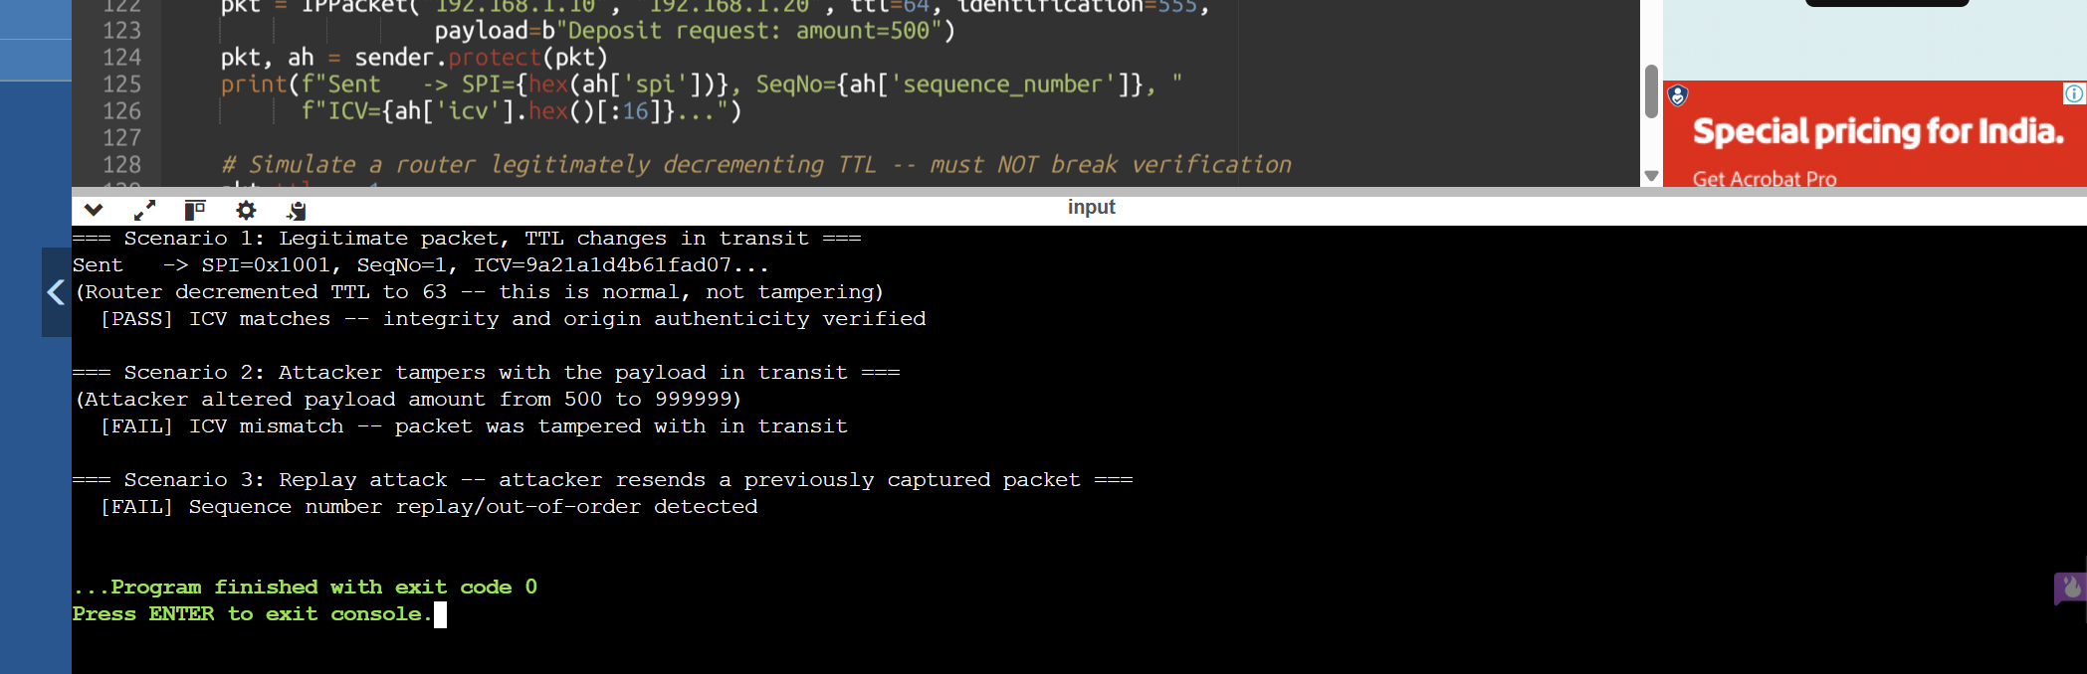

- Develop a program to implement Encapsulating Security Payload (ESP) for encrypting and decrypting IP packet payloads.
IPSec Encapsulating Security Payload (ESP)
Steps:
- Build ESP structure: header (SPI + sequence number, sent in clear) → IV → AES-256-CBC ciphertext of (payload + padding + pad-length byte + next-header byte).
- Encrypt first, then compute HMAC-SHA256 over header+IV+ciphertext — the secure Encrypt-then-MAC composition.
- Receiver verifies the ICV before attempting decryption ("fail closed") — this is deliberate: never run decryption logic on unauthenticated ciphertext, since doing so opens the door to padding-oracle attacks.
- Only after the MAC passes does the receiver decrypt and strip padding.
- Verified: correct round-trip decryption, a flipped ciphertext bit correctly rejected, and a fully forged packet (no valid key) correctly rejected.

Code:
import os
import hmac
import hashlib
import struct

BLOCK_SIZE = 16 # keystream block size in bytes (kept 16 to mirror AES block size)

# ---------- Step 1: SHA-256 keystream cipher (stdlib-only AES-CTR substitute) ----------
def keystream_xor(data: bytes, key: bytes, nonce: bytes) -> bytes:
"""
Generate a keystream long enough to cover `data` by hashing
key || nonce || counter for counter = 0, 1, 2, ...
and XOR it with data. Symmetric: calling this again with the
same key/nonce on the ciphertext recovers the plaintext.
"""
out = bytearray()
counter = 0
while len(out) < len(data):
block_input = key + nonce + struct.pack("!I", counter)
keystream_block = hashlib.sha256(block_input).digest() # 32 bytes
out.extend(keystream_block)
counter += 1
keystream = bytes(out[:len(data)])
return bytes(a ^ b for a, b in zip(data, keystream))

# ---------- Step 2: ESP padding (RFC 4303 sec 2.4) ----------
def pad_for_esp(payload: bytes, trailer_len: int = 2) -> tuple[bytes, int]:
total_len = len(payload) + trailer_len
pad_len = (BLOCK_SIZE - (total_len % BLOCK_SIZE)) % BLOCK_SIZE
padding = bytes(range(1, pad_len + 1))
return payload + padding, pad_len

def unpad(data: bytes, pad_len: int) -> bytes:
return data[:-pad_len] if pad_len else data

# ---------- Step 3: ESP sender ----------
class ESP_Sender:
def __init__(self, enc_key: bytes, mac_key: bytes, spi: int):
self.enc_key = enc_key # confidentiality key
self.mac_key = mac_key # HMAC integrity key (separate key -- never reuse!)
self.spi = spi
self.sequence_number = 0

def protect(self, payload: bytes, next_header: int = 6):
self.sequence_number += 1
esp_header = struct.pack("!II", self.spi, self.sequence_number)

padded, pad_len = pad_for_esp(payload)
trailer = struct.pack("!BB", pad_len, next_header)
plaintext_block = padded + trailer

nonce = os.urandom(BLOCK_SIZE)
ciphertext = keystream_xor(plaintext_block, self.enc_key, nonce)

# Encrypt-then-MAC: authenticate header + nonce + ciphertext
icv = hmac.new(self.mac_key, esp_header + nonce + ciphertext, hashlib.sha256).digest()

return {
"esp_header": esp_header,
"nonce": nonce,
"ciphertext": ciphertext,
"icv": icv,
}

# ---------- Step 4: ESP receiver ----------
class ESP_Receiver:
def __init__(self, enc_key: bytes, mac_key: bytes, spi: int):
self.enc_key = enc_key
self.mac_key = mac_key
self.spi = spi

def unprotect(self, esp_packet: dict):
esp_header = esp_packet["esp_header"]
nonce = esp_packet["nonce"]
ciphertext = esp_packet["ciphertext"]
icv = esp_packet["icv"]

recv_spi, seq_no = struct.unpack("!II", esp_header)
if recv_spi != self.spi:
print(" [FAIL] SPI mismatch")
return None

# (a) Verify ICV FIRST -- never decrypt unauthenticated ciphertext
expected_icv = hmac.new(self.mac_key, esp_header + nonce + ciphertext, hashlib.sha256).digest()
if not hmac.compare_digest(expected_icv, icv):
print(" [FAIL] ICV verification failed -- ciphertext tampered / packet forged. "
"Decryption ABORTED (fail closed).")
return None
print(" [OK] ICV verified -- authenticity and integrity confirmed")

# (b) Only now decrypt (same XOR keystream operation undoes itself)
plaintext_block = keystream_xor(ciphertext, self.enc_key, nonce)

pad_len, next_header = struct.unpack("!BB", plaintext_block[-2:])
payload = unpad(plaintext_block[:-2], pad_len)
print(f" [OK] Decrypted payload (seq={seq_no}, next_header={next_header})")
return payload

# ---------- Demonstration ----------
if __name__ == "__main__":
enc_key = os.urandom(32)
mac_key = os.urandom(32) # separate HMAC key -- never reuse the encryption key!
spi = 0x2002

sender = ESP_Sender(enc_key, mac_key, spi)
receiver = ESP_Receiver(enc_key, mac_key, spi)

print("=== Scenario 1: Legitimate encrypt -> decrypt round trip ===")
original = b"Confidential: transfer $2500 to account 778899"
esp_packet = sender.protect(original)
print(f"Original payload : {original}")
print(f"Ciphertext (hex) : {esp_packet['ciphertext'].hex()[:48]}...")
recovered = receiver.unprotect(esp_packet)
print(f"Recovered payload : {recovered}")
print(f"Match original? : {recovered == original}")

print("\n=== Scenario 2: Attacker flips a bit in the ciphertext ===")
tampered_packet = dict(esp_packet)
ct = bytearray(esp_packet["ciphertext"])
ct[0] ^= 0xFF
tampered_packet["ciphertext"] = bytes(ct)
print("(Attacker modified 1 byte of ciphertext)")
result = receiver.unprotect(tampered_packet)
print(f"Result: {result}")

print("\n=== Scenario 3: Attacker forges an ESP packet without the MAC key ===")
forged = {
"esp_header": struct.pack("!II", spi, 99),
"nonce": os.urandom(BLOCK_SIZE),
"ciphertext": os.urandom(32),
"icv": os.urandom(32),
}
result = receiver.unprotect(forged)
print(f"Result: {result}")

Output:
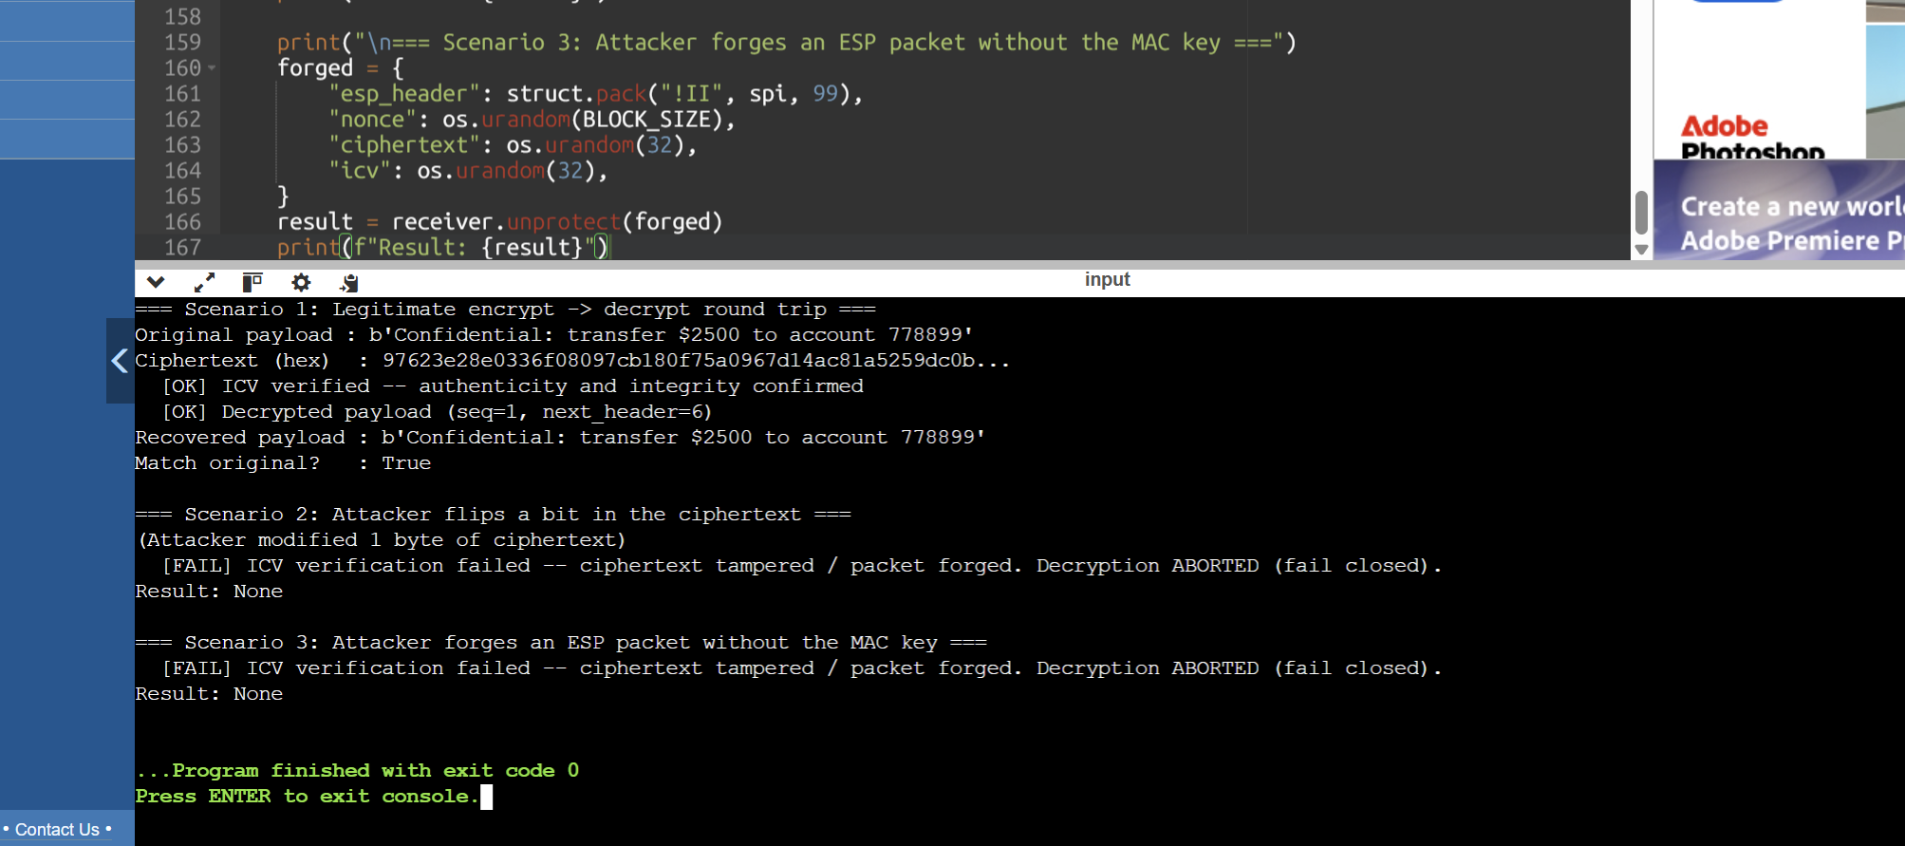

RUBRICS FOR CALCULATION:

Criteria | Weightage | Level 4 (Exemplary) | Level 3 (Proficient) | Level 2 (Developing) | Level 1 (Beginning)
Problem Understanding | 20% | Clearly understands problem constraints, edge cases, and competitive requirements | Understands problem with minor gaps in constraints | Partial understanding; misses key constraints | Misinterprets problem or constraints
Algorithm | 25% | Selects optimal algorithm with best time and space complexity for competitive constraints | Uses efficient algorithm with minor scope for improvement | Uses basic/inefficient approach | No clear algorithmic approach
Code Implementation | 20% | Writes correct, efficient, and clean code that passes all constraints | Code works with minor errors or inefficiencies | Partially correct code; fails for some cases | Code does not execute or gives incorrect results
Competitive Performance | 20% | Solves problem within time limits and handles large inputs effectively | Solves within acceptable time with minor delays | Struggles with time limits or larger inputs | Unable to solve within time constraints
Test Case Handling | 15% | Handles all test cases including edge and hidden cases | Handles most test cases | Misses important edge cases | Fails on multiple test cases

